NAME: S. DHARANI
REG NO: 192472364
COURSE CODE: DSA0401
NUMPY / PANDAS ANALYSIS – QUESTIONS AND ANSWERS
QUESTION 18: DESCRIPTIVE STATISTICS AND GRAPHS FOR AGE AND BODY FAT
AIM:
To calculate mean, median and standard deviation and draw boxplots, a scatter plot and a Q-Q plot for age and body fat.
ALGORITHM:
1. Import Pandas, Matplotlib and SciPy stats.
2. Create a DataFrame with age and body-fat values.
3. Calculate mean, median and standard deviation.
4. Draw boxplots for age and body fat.
5. Draw a scatter plot of age against body fat.
6. Draw Q-Q plots for both variables.
CODE:
import pandas as pd
import matplotlib.pyplot as plt
from scipy import stats
df = pd.DataFrame({
"Age": [23, 25, 28, 30, 32, 35, 38, 40, 42],
"Fat": [18, 20, 22, 24, 25, 27, 29, 31, 33]
})
print(df.agg(["mean", "median", "std"]))
df[["Age", "Fat"]].plot(kind="box")
plt.title("Boxplots of Age and Body Fat")
plt.show()
plt.scatter(df["Age"], df["Fat"])
plt.xlabel("Age")
plt.ylabel("Body Fat (%)")
plt.title("Age vs Body Fat")
plt.show()
stats.probplot(df["Age"], dist="norm", plot=plt)
plt.title("Q-Q Plot of Age")
plt.show()
stats.probplot(df["Fat"], dist="norm", plot=plt)
plt.title("Q-Q Plot of Body Fat")
plt.show()
INPUT:
Sample values are provided in the code for 9 adults. Replace them with the 18 values from your question screenshot.
OUTPUT:
Mean, median and standard deviation are printed. Four figures are displayed: boxplot, scatter plot, Q-Q plot for age and Q-Q plot for body fat.
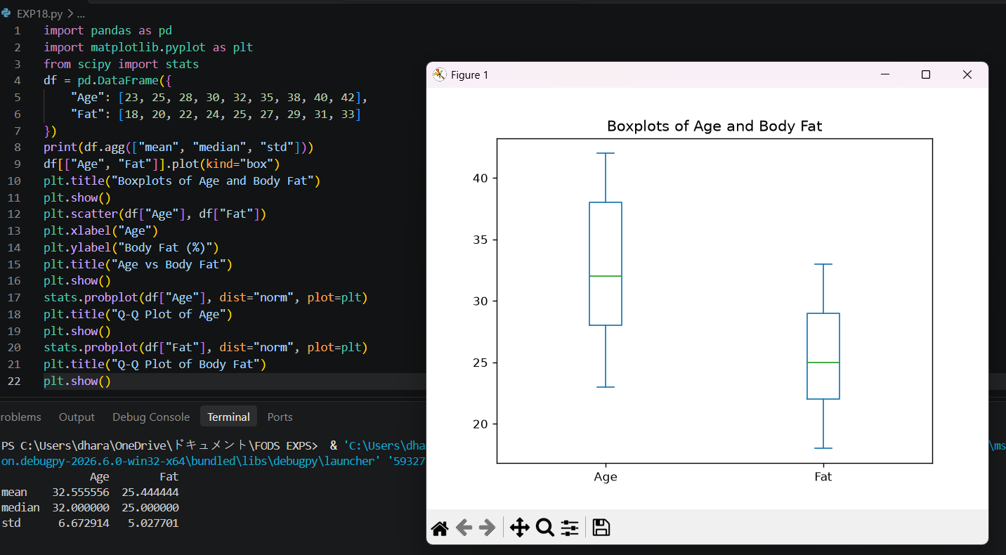

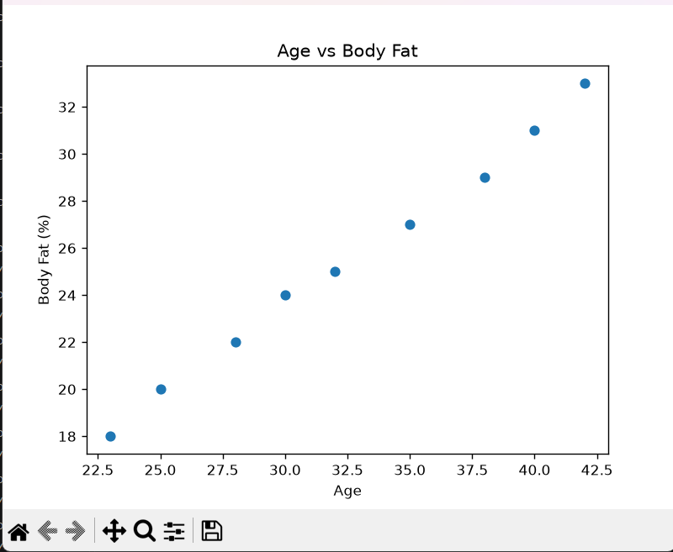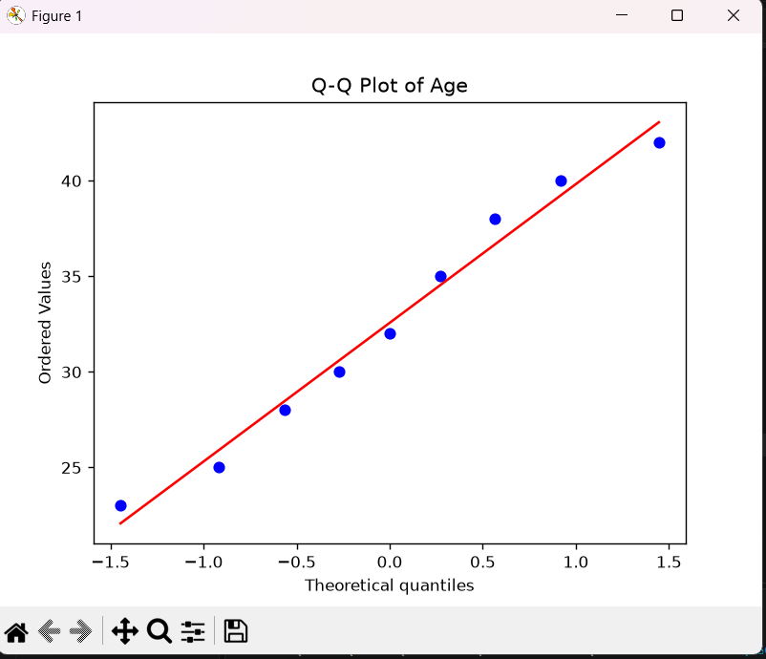
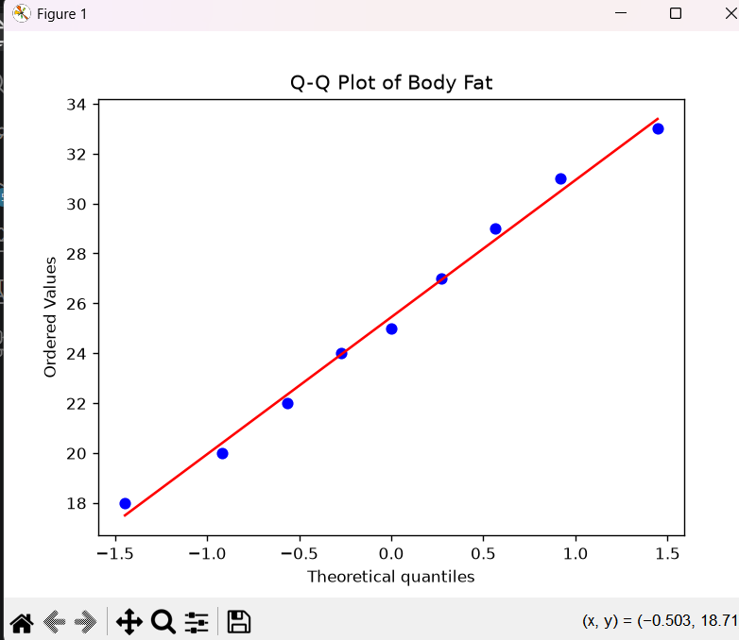

RESULT:
Descriptive statistics and the required plots were generated successfully.

